YD’s DataViz 3: Long-Term Unemployment Analysis

Find the Long-Term Unemployment Analysis using the P1-Long-Term-Unemployment-Statistics dataset.

Let’s Do It:

1. All Men and Women Combined

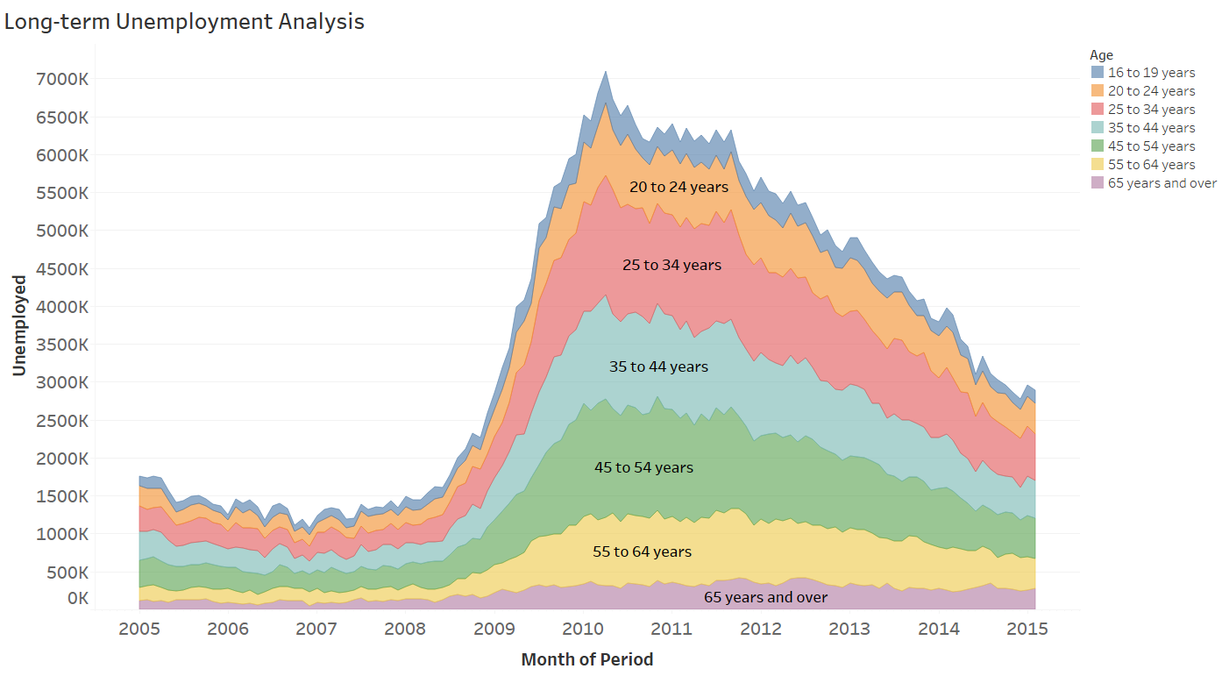

2. Men

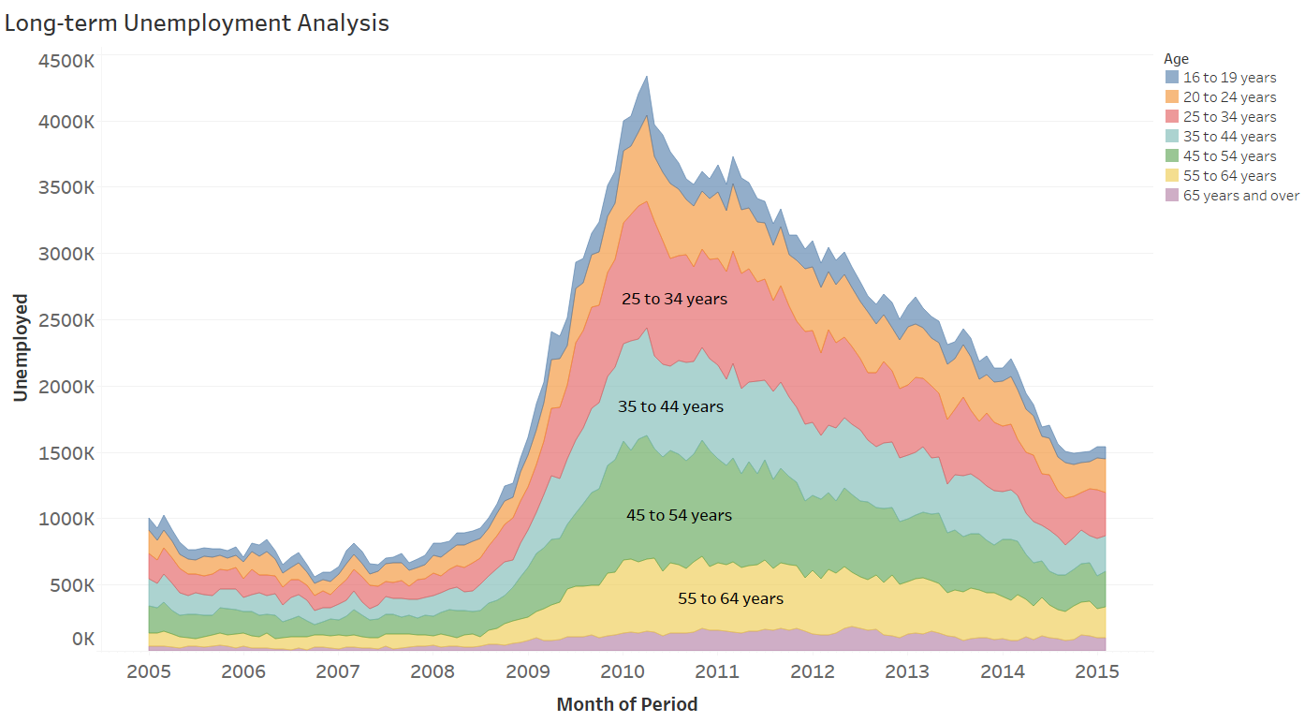

1. Women

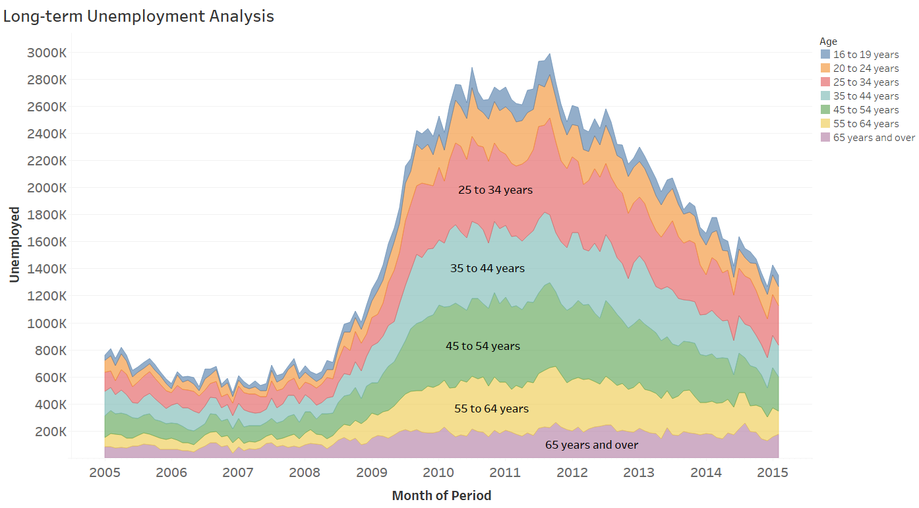

Thanks for reading till the end hope so you liked it leave your opinion about it in the comment section.